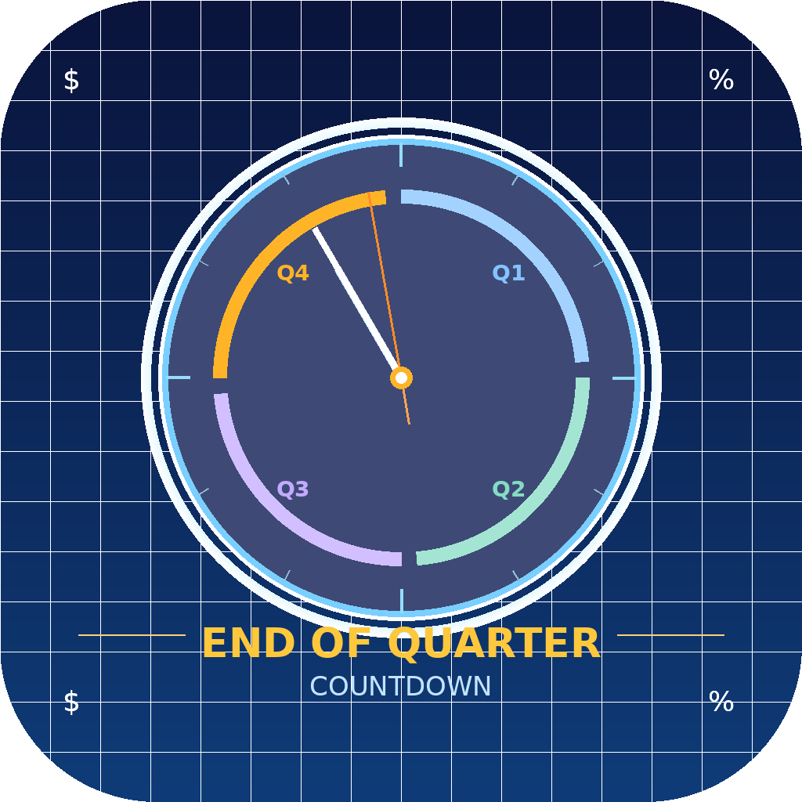
End of Quarter Countdown
User Guide
macOS 13 (Ventura) and later

Version | Current release — see About section in the app
Platform | macOS 13 Ventura or later
Author | Ian Hawkins
Contact | ian@hawkinsmultimedia.net

1. Overview
End of Quarter Countdown is a lightweight macOS menu bar app that keeps your current fiscal quarter’s end date in constant view — without cluttering your Dock or desktop.

The app tracks five quarters at once:
- Q1 – Q4 of the current fiscal year
- Q1 of the next fiscal year (used as a transition buffer)

It automatically advances to the next quarter when the current one ends, updates the fiscal-year label in the menu bar, and warns you when it is time to load a new year’s dates.

Key features
- Menu bar display — always-visible countdown, e.g. FY26 Q2 · 45d
- Popup panel — days remaining, current week, and weeks left in the quarter
- Five-quarter tracking — seamless roll-over between fiscal years
- Web sync — fetch dates automatically from a configurable URL
- Manual date editor — pick any end date with a standard date picker
- New-FY warning — orange icon and banner when dates need refreshing
- Launch at Login — optional auto-start with macOS
- Time zone-aware — recalculates instantly when you change time zone

2. Getting Started

Installation
Download and open the app from the source listed on the project page.

1 | Move End of Quarter Countdown.app to your Applications folder.
2 | Double-click to launch. macOS may ask for permission on first run — click Open.
3 | The calendar icon appears in the menu bar. No Dock icon is shown.
4 | Use the Cloud Sync to collect the current Fiscal Year data or create custom dates using the date editor panel (sliders icon) function.
5 | If you wish the application to launch on start-up, Tick the ‘Launch at Login’ box on the popup panel.

3. The Menu Bar
The app always displays a compact label in the macOS menu bar. No interaction is required to see the countdown.


Normal state
Icon | End of Quarter icon
Label format | FY26 Q2 · 45d
FY badge | Shows the fiscal year of the current quarter (e.g. FY26)
Quarter number | Q1 – Q4 (Q5 is shown as Q1 of the next FY)
Days remaining | Calendar days until midnight on the quarter end date

Warning state
⚠️ Orange warning indicator
When you are counting down to the final stored quarter (next FY Q1) and fewer than 70 days remain, the menu bar icon changes with warning triangle and the label turns orange.
This means your quarter dates need to be refreshed for the upcoming fiscal year.


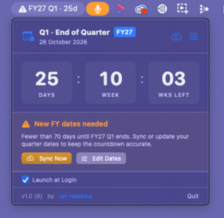

4. The Popup Panel
Click the menu bar label to open the popup panel. Click anywhere outside the panel to close it.

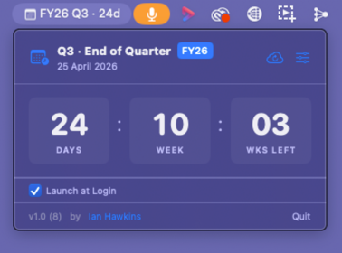

Header
Quarter title | Shows the current quarter and fiscal year badge
End date | The calendar end date of the current quarter in long format
Sync button | Fetches updated dates from the configured web URL (cloud icon)
Edit button | Opens the date editor panel (sliders icon)

Countdown display
Three tiles show at a glance:

DAYS  Calendar days until the quarter end date | WEEK  Current week number within the quarter | WKS LEFT  Full weeks remaining in the quarter

Footer
Launch at Login | Toggle checkbox — starts the app automatically when you log in to macOS
Version info | Shows the current app version and build number
By Ian Hawkins | Mailto link to the author’s email address
Quit | Exits the app completely

5. Setting Quarter Dates
Quarter end dates can be set in two ways: syncing from a web page automatically, or editing them manually. Both methods save the dates immediately and persist across app restarts.
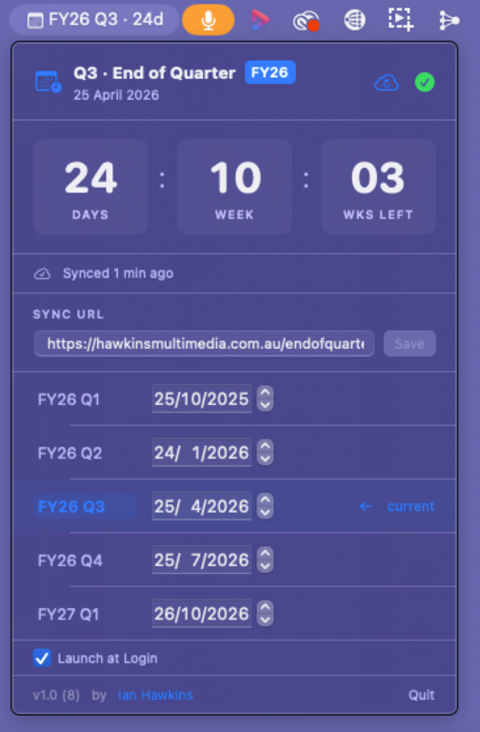

Opening the date editor
sliders icon (top-right of the popup header) to open the date editor. Click it again (it becomes a green tick) to close.

Method 1 — Sync from the web
This is the recommended method. The app fetches dates from a web page and populates all five quarters automatically.

1 | sliders icon.
2 | Sync URL field (see Section 6 for URL format)
3 | Save if you changed the URL.
4 | cloud sync icon in the header, or the Sync Now button in the warning banner if it is visible.

ℹ️ Sync status
After a successful sync, the editor shows the time of the last sync (e.g. “Synced 2 minutes ago”). If an error occurs, an orange message describes the problem.

Method 2 — Edit dates manually
If you prefer not to use web sync, or need to override a specific date, use the manual date pickers.

1 | sliders icon.
2 | Each row shows a quarter label (e.g. FY26 Q1) and a date picker.
3 | Click a date picker to choose the end date for that quarter.
4 | Changes save automatically — no separate Save button is needed for dates.

The current quarter is highlighted with an accent-colour background and marked with “current” on the right.

The five rows correspond to:

Row 1 | Q1 end date for the current fiscal year
Row 2 | Q2 end date
Row 3 | Q3 end date
Row 4 | Q4 end date
Row 5 | Q1 end date of the next fiscal year (transition buffer)

6. Web Sync

Default URL
https://hawkinsmultimedia.com.au/endofquarter.html
You can replace this with any URL that serves a page in the required format.

Page format
The sync page must contain five lines matching this pattern (in order Q1 – Q4 of the current FY, then Q1 of the next FY):

FY26Q1 : 25/10/2025
FY26Q2 : 25/01/2026
FY26Q3 : 25/04/2026
FY26Q4 : 25/07/2026
FY27Q1 : 25/10/2026

FY label | Fiscal year (e.g. FY26). Stored per quarter and shown in the UI.
Quarter | Q1 – Q4 for the current year; Q1 for the next year on the fifth line.
Date format | dd/mm/yyyy (day first, then month, then four-digit year).
Separator | Space – colon – space between the label and the date.

ℹ️ Any hosting will work
The page can be a plain HTML file, a static site, or any web server output — as long as the five lines appear somewhere in the page source.

Sample html body data, create your own URL and page with this example.
<!doctype html>
<html>
<head>
<meta charset="UTF-8">
<title>Untitled Document</title>
</head>

<body>
<p>FY26Q1 : 25/10/2025 </p>
<p>FY26Q2 : 24/01/2026 </p>
<p>FY26Q3 : 25/04/2026 </p>
<p>FY26Q4 : 25/07/2026 </p>
<p>FY27Q1 : 26/10/2026 </p>
</body>
</html>

Changing the sync URL
1 | sliders icon.
2 | Click the Sync URL field and type or paste the new URL.
3 | Save. The new URL is remembered between launches.
4 | Trigger a sync with the cloud icon to test the new URL immediately.

⚠️ URL validation
Only http:// and https:// URLs are accepted. The Save button is disabled if the URL is invalid or unchanged.

7. New Fiscal Year Warning
The app tracks a fifth quarter — Q1 of the next fiscal year — to give you a buffer when your current FY ends. When the app starts counting down to that fifth quarter and fewer than 70 days remain, a warning is triggered.
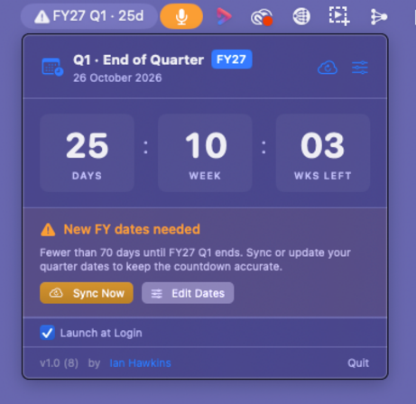

What you will see
- Menu bar: The calendar icon changes to with warning triangle.
- Popup banner: An orange “New FY dates needed” banner appears below the countdown tiles.

Resolving the warning
The banner offers two actions:

Sync Now | Fetches updated dates from the configured URL. The warning clears automatically once the new dates move the countdown beyond the fifth quarter.
Edit Dates | Opens the date editor so you can enter new dates manually.

The warning disappears automatically once the fifth-quarter date is updated and is no longer the active countdown target.

8. Time zone Handling
Quarter end dates are stored as calendar day values (day, month, year) rather than fixed timestamps. This means the date 25 October always means 25 October, regardless of where you are in the world.

If you travel and change your Mac’s time zone in System Settings, the app detects the change and recalculates the days remaining using the correct local calendar. No restart is needed.

ℹ️ Background refresh
The app also rechecks the countdown every 10 minutes as a safety net, in addition to responding to time zone changes.

9. Launch at Login
You can configure the app to start automatically each time you log in to macOS.

1 | Click the menu bar label to open the popup.
2 | Launch at Login in the footer of the popup.

This setting is saved immediately and remembered between launches. You can also control it from System Settings → General → Login Items on macOS 13 and later.

10. Troubleshooting

Sync returns “No quarter dates found on page”
- Confirm that the sync URL is correct and the page is publicly accessible.
- Check that the page source contains lines in the exact format shown in Section 6.
- Verify that the FY label immediately precedes Q1 with no space (e.g. FY26Q1, not FY26 Q1).

Days remaining does not change after a time zone switch
- The recalculation happens within seconds of a time zone change. Wait a moment and check again.
- If the issue persists, quit and relaunch the app.

The menu bar label shows “Q1 · 0d” with no FY badge
- No quarter dates have been synced from the web yet. Open the editor and sync, or set dates manually.

App does not start at login
- Toggle Launch at Login off, then on again.
- Check System Settings → General → Login Items and ensure the app is listed there.

Cannot save the sync URL
- The URL must begin with http:// or https://. The Save button is disabled for any other scheme.

11. About
App name | End of Quarter Countdown
Author | Ian Hawkins
Email | ian@hawkinsmultimedia.net
GitHub | github.com/ianhawki/EndOfQuarterCountdown
License | MIT
Platform | macOS 13 (Ventura) or later
Built with | Swift 5, SwiftUI, Xcode 15+

The current app version and build number are shown at the bottom of the popup panel. Pull requests and issue reports are welcome on GitHub.

— End of document —

